**8 SCIENCE ENERGY EFFICIENCY ASSIGNMENT 2016**

[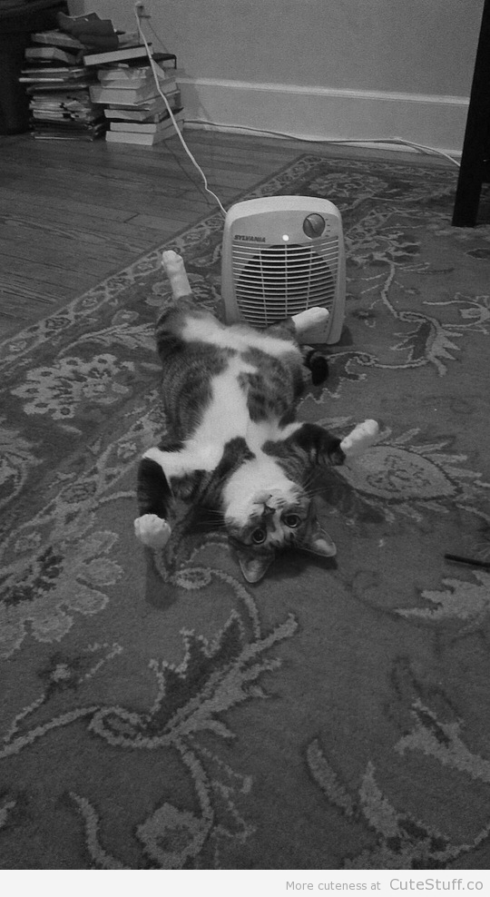](http://www.google.com.au/url?sa=i&rct=j&q=cat+energy+efficient&source=images&cd=&cad=rja&uact=8&docid=ivsTDEQK48Y_OM&tbnid=4-pH1Rv2FuCoKM:&ved=0CAYQjRw&url=http://cutestuff.co/2013/02/cat-loves-heater/&ei=Q1wpU4vaJYnbkAXQsYGgBQ&psig=AFQjCNGfNkyt67rC-AxndFBpmE3WqdfEsA&ust=1395305910912376)

Name:______________________ Teacher:____________________

Form:______________________ Due date:___________________

**Plagiarism**

You must write in your own words, not copy sentences word for word from another student or another source.

Plagiarising = instant zero on assignment and you will have to re-do it.

**Assessment policy**

Give me a sick note/legitimate reason from parent BEFORE due date = new negotiated due date.

One day late = -20% taken off mark

Two days late = -40% taken off mark

Three days late = mark of zero given

After three days, students are required to attend a detention and are still required to submit the assignment.

**If you are not at school the day this assignment is due, please email it to your teacher by 4pm on the due date.**

**Teacher email: __________________________@aranmore.wa.edu.au**

**Aim:** to investigate different ways to improve energy efficiency in the home.

**SECTION 1: ANALYSE THE HOME**

**1.** On the picture of the house below, mark clearly six situations where energy is not being used efficiently. Place a number (1-6) and colour the number in highlighter so it can be clearly seen.

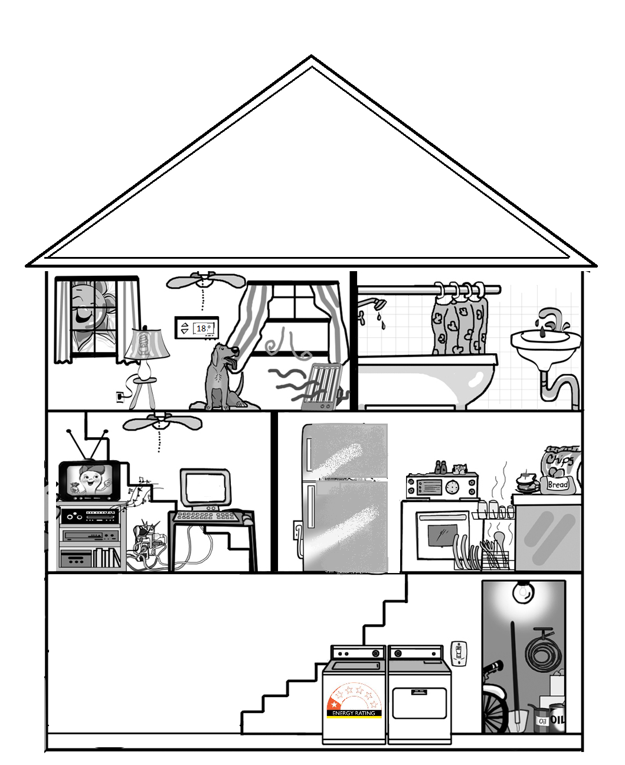

**2.** In the table below, next to each number, describe how energy is not being used efficiently and describe how you could make the situation more energy efficient. (12 marks)

|  |  |  |
| --- | --- | --- |
| Situation  number | Describe how energy is not being used  efficiently or is being wasted | Describe how you could make the situation more  energy efficient and waste less energy |
| 1 |  |  |
| 2 |  |  |
| 3 |  |  |
| 4 |  |  |
| 5 |  |  |
| 6 |  |  |

**SECTION 2: ONLINE RESEARCH**

**Choose two of the following energy saving home features then answer the questions below.**

•Double glazed windows •Gas hot water system •Solar panels

•Compact fluorescent lights • Front loader washing machine

Websites to use: http://sustainability.ceres.org.au/ synergy.net.au

https://www.sa.gov.au/topics/water-energy-and-environment

**1a)** Energy saving feature: __________________________________________________________________________

**b)** Where is this feature used in the home? (1 mark)

_________________________________________________________________________________________________

**c)** Find an estimate how much it will cost to put in the home (look at websites that sell the item in Australia). (1 mark)

_________________________________________________________________________________________________

_________________________________________________________________________________________________

**d)** Describe how this feature saves energy (at least two sentences). (2 marks)

_________________________________________________________________________________________________

_________________________________________________________________________________________________

_________________________________________________________________________________________________

_________________________________________________________________________________________________

_________________________________________________________________________________________________

_________________________________________________________________________________________________

**e)** Describe how widely used this feature is in Australia? (How common is it in households in Australia) (2 marks)

(at least two sentences).

_________________________________________________________________________________________________

_________________________________________________________________________________________________

_________________________________________________________________________________________________

_________________________________________________________________________________________________

_________________________________________________________________________________________________

**2a)** Energy saving feature: __________________________________________________________________________

**b)** Where is this feature used in the home? (1 mark)

_________________________________________________________________________________________________

**c)** Estimate how much it will cost to put in the home (look at websites that sell the item in Australia). (1 mark)

_________________________________________________________________________________________________

_________________________________________________________________________________________________

**d)** Describe how this feature saves energy (at least two sentences). (2 marks)

_________________________________________________________________________________________________

_________________________________________________________________________________________________

_________________________________________________________________________________________________

_________________________________________________________________________________________________

_________________________________________________________________________________________________

_________________________________________________________________________________________________

**e)** Describe how widely used this feature is in Australia? (How common is it in households in Australia) (2 marks)

(at least two sentences).

_________________________________________________________________________________________________

_________________________________________________________________________________________________

_________________________________________________________________________________________________

_________________________________________________________________________________________________

_________________________________________________________________________________________________

**Reference list**

Minimum of two references. (1 mark)

Referenced using the APA referencing style. (1 mark)

_________________________________________________________________________________________________

_________________________________________________________________________________________________

_________________________________________________________________________________________________

_________________________________________________________________________________________________

_________________________________________________________________________________________________

_________________________________________________________________________________________________

_________________________________________________________________________________________________

_________________________________________________________________________________________________

_________________________________________________________________________________________________

_________________________________________________________________________________________________

_________________________________________________________________________________________________

_________________________________________________________________________________________________

_________________________________________________________________________________________________

_________________________________________________________________________________________________

Presented neatly and clearly. (1 mark)

Correct grammar and spelling. (1 mark)

Total mark: /28

Percentage: %

Teacher’s comments:

__________________________________________________________________________________________________________

__________________________________________________________________________________________________________

__________________________________________________________________________________________________________

**APA referencing guide**

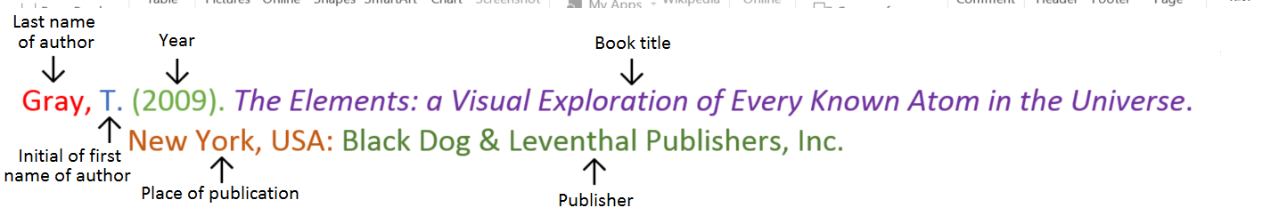**Book**

**Book with two authors**

Shermer, M., & Benjamin, A. (2006). *Secrets of Mental Math: The Mathemagician’s Guide to Lightning Calculation and Amazing Mental Math Tricks*. New York, USA: Three Rivers Press.

**Book with three or more authors**

Bulliet, R. W., Alley, R. B., Broecker, W. S., & Denton, G. H. (2011). *The fate of Greenland: Lessons from abrupt climate change*. Cambridge, MA: MIT Press.

**Book with editor**

Kasdorf, W. E. (Ed). (2003). *The Columbia guide to digital publishing*. New York, USA: Columbia University Press.

**Book with different editions**

Nagle, G., & Cooke, B. (2012). *Geography Study Guide: Oxford Ib Diploma Programme* (2nd ed.). Oxford, UK: Oxford University Press.

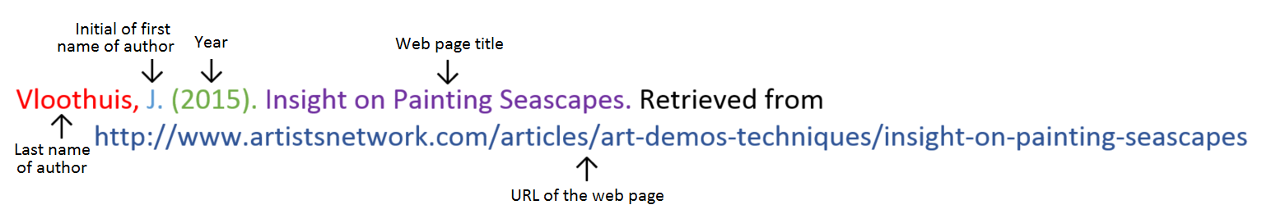**Website**

**Website with no author** (put title of page at the front)

Aranmore Catholic College. (2014). Retrieved from

http://www.aranmore.wa.edu.au/

**Website with no date**

The Zadkine Museum. (n.d). Retrieved http://www.france.fr/en/museums/zadkine-museum.html

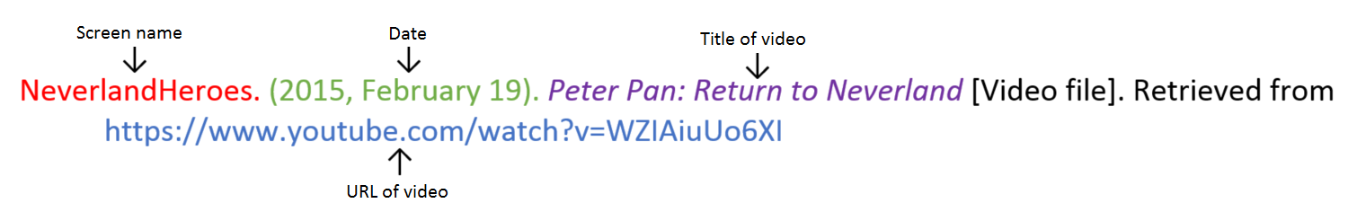**Video file**